Instruction on how to us the Configurator Program

First download the configurator program to your hard drive.
Once this is done, right click on the program icon and select “Create Shortcut”
Once you have created the shortcut, right click on the shortcut and select properties. Edit the Shortcut as shown below and add a space –d to the end of the Target line:

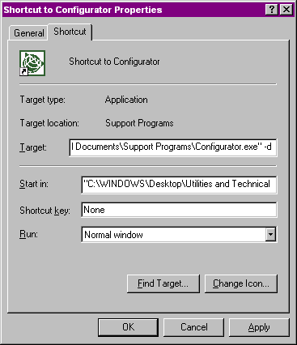

Now that this is done you will need the following in order to program the SQ or iQ receivers:
1. Starter Kit
2. Configurator program as edited above.
3. The customer’s configuration. (Protocols, baud rates, messages and frequency)

Connect the receiver to be programmed into the starter kit. Connect your Starter Kit to one of your PC COM ports and power up the receiver.
Now start the configurator with the new shortcut you created above.
Select either the SQ or iQ from the choices listed as shown below:

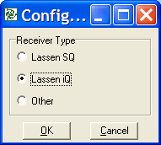

Below is the default Screen you will see for the SQ:
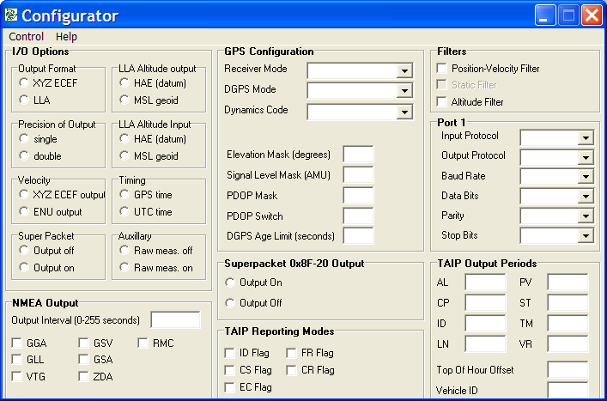

Below is the default Screen you will see for the iQ:
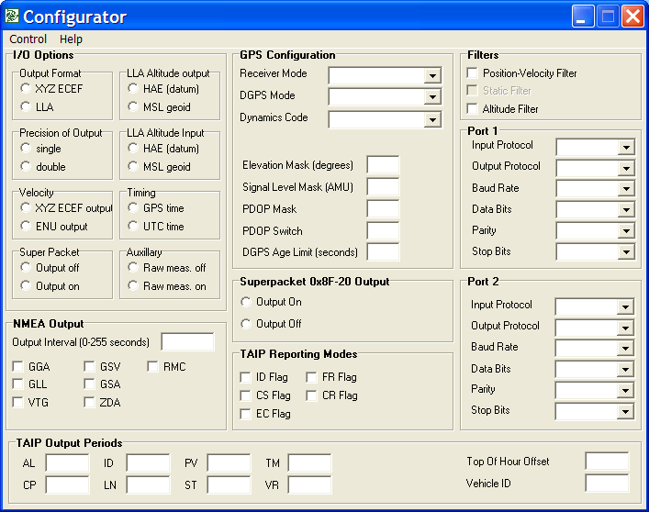

Note:
The difference between the SQ and iQ configuration windows is the support for the secondary COM port.

Programming Steps

Now load the settings from the SQ or iQ receiver.
Loading settings from the receiver first will enable you to only change the settings required by the customer while retaining our default settings.

- From the Configurator tool bar select “Control” and then “Load from Receiver”. Once this is done the screen below will appear.
- Select the PC COM Port your SQ or iQ receiver is connected too.

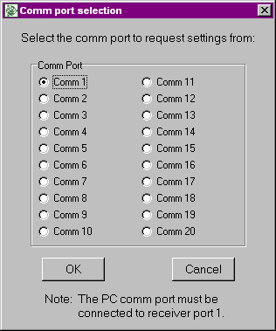

Note:
You can only use this program at default baud rate of:
9600,8,O,1 TSIP In/Out

Below is what the Configurator screen should resemble once you have downloaded the configuration from the receiver:

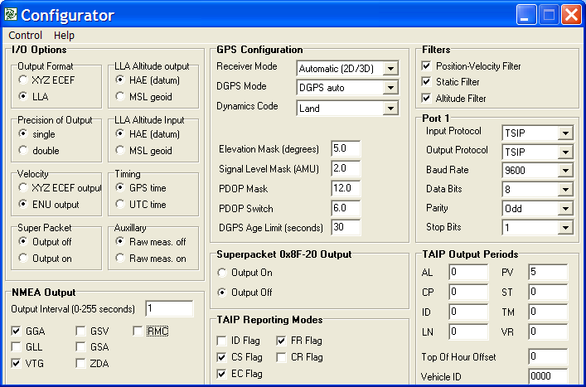

Note:
Above is the SQ’s configuration screen

3. Now change the configuration to what the customer has requested.
Once the configuration is done save it to a .dat file by selecting “Control” from the toolbar then “Save settings”. Once this is done just name and save the .dat file.

Note: If configuring only one unit and you don’t need a .dat file then select “Control” then “Configure Receivers”. Pick the Com port your receiver is connected too and select “OK” This program will support multiple port configurations.

Once the .dat file is saved you can send it to the customer along with the Configurator program and the customer can configure his own receivers. The next section will show you how to load a .dat file to an SQ or iQ receiver.

